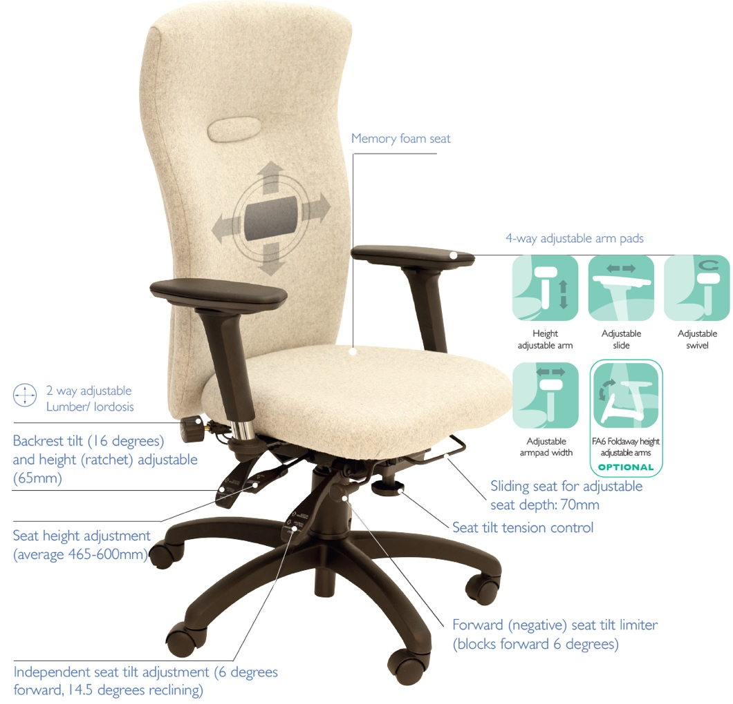
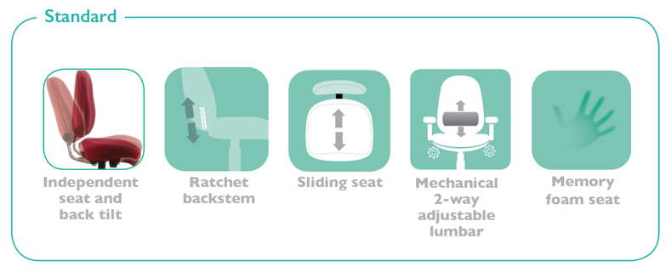
The square back style Spynamics models provide a cost effective ‘Access to Work’ seating solution; where a comfortable, supportive and adjustable ‘bad back chair’ is required.
SD13
SD14
SD12
SD12 SD13 SD14
Everyday ergonomic Back Care chairs
For more information and prices, please contact Phil Pask on 07803 120155

Ergonomic features include:

- Heavy duty 6-way adjustable mechanism provides correct posture and personalised support
- 5-year warranty/8 hour daily use by up to 23.5 stone users (150kg) for single user application
- Overwork/overweight warranty available for 3 shift pattern use and users over 23.5 stone
- Seat height min/max adjustment range meets the FIRA Ergonomic Excellence Award criteria
- Comfort and support enhanced by a memory foam layered seat
- Choice of 3 contoured backs, with 2-way built-in variable lumbar support
- 4-way adjustable arms fitted as standard, other arm options are also available
- Optional coccyx cut out available as well as a selection of other seat sizes
- Memory foam backs and an adjustable memory foam headrest are among the optional extras

